**3.4 BAR CHARTS**

**Practice Exercise – Easy**

**Directions (Q. Nos. 1 − 4):** *Answer the following questions on the basis of the information given below.*

FEI for a country in a year, is the ratio (expressed as a percentage) of its foreign equity inflows to its GDP.

The following figure displays the FEIs for selected Asian countries for 1997 and 1998. **[CAT 2000]**

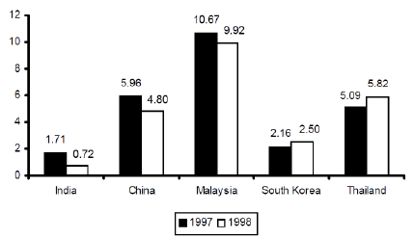

1. The country with the highest percentage change in FEI in 1998 relative to its FEI in 1997, is

a. India b. China c. Malaysia d. Thailand

2. Based on the data provided, it can be concluded that

a. absolute value of foreign equity inflows in 1998 was higher than that in 1997 for both Thailand and South Korea.

b. absolute value of foreign equity inflows was higher in 1998 for Thailand and lower for China than the corresponding values in 1997.

c. absolute value of foreign equity inflows was lower in1998 for both India and China than the corresponding values in 1997.

d. None of the above can be inferred

3. It is known that China’s GDP in 1998 was 7% higher than its value in 1997, while India’s GDP grew by 2% during the same period. The GDP of South Korea, on the other hand, fell by 5%. Which of the following statements is/are true?

I. Foreign equity inflows to China were higher in 1998 than in 1997.

II. Foreign equity inflows to China were lower in 1998 than in 1997.

III. Foreign equity inflows to India were higher in 1998 than in 1997.

IV. Foreign equity inflows to South Korea decreased in1998 relative to 1997.

V. Foreign equity inflows to South Korea increased in 1998 relative to 1997.

a. I, III and IV b. II, III and IV

c. I, III and V d. II and V

4. China’s foreign equity inflows in 1998 were 10 times that of India. It can be concluded that

a. China’s GDP in 1998 was 40% higher than that of India

b. China’s GDP in 1998 was 70% higher than that of India

c. China’s GDP in 1998 was 50% higher than that of India

d. no inference can be drawn about relative magnitudes of China’s and India’s GDPs

**Directions (Q. Nos. 5 − 10):** *Answer the following questions on the basis of the information given below.*

The following bar chart gives the average of Sehwag, Yuvraj and Gautam in 4 seasons of IPL.

Average = 

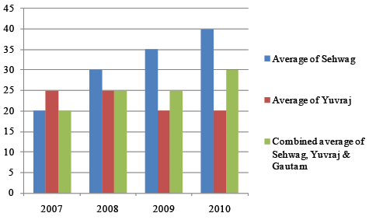

5. In which year did Gautam show the highest percentage growth in average? (all players played same number of matches)

a. 2008 b. 2009

c. 2010 d. Cannot be determined

6. In which year was the average of Sehwag the highest in total average? (all players played same number of matches)

a. 2007 b. 2008

c. 2009 d. 2010

7. Assuming the total runs scored by the 3 players in all are same for year 2008 and 2009, the number of runs scored by virtue of 4’s and 6’s are in ratio 3 : 2 and 2 : 3 in 2008 and 2009 respectively. What is the increase in number of sixes if each played 20 matches in both the year? (Assume all runs scored through 4’s and 6’s only)

a. 300 b. 250

c. 375 d. None of these

8. The ratio of number of matches played by Sehwag, Yuvraj and Gautam is 2 : 3 : 4 and 2 : 1 : 3 in 2009 and 2010 respectively, then what is the change in average of Gautam?

a. 54.38 b. 18.27

c. 12.91 d. None of these

9. For which year is the ratio of average of Sehwag to the average of Yuvraj the highest?

a. 2007 b. 2008

c. 2009 d. 2010

10. Yuvraj, Sehwag and Gautam played 16 matches each in all the 4 years, then total runs scored by Gambhir in 4 years is:

a. 1200 b. 1480

c. 1360 d. Cannot be determined

**Directions (Q. Nos. 11** − 1**4):** *Answer the following questions on the basis of the information given below.*

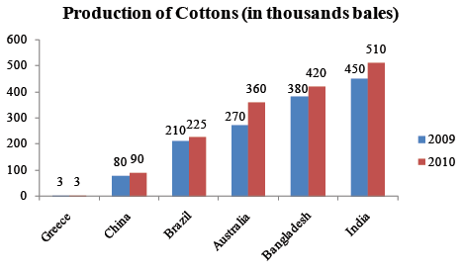

11. The total production in 2010 of the countries that individually show a growth of more than 10% from 2009 to 2010 forms what proportion of the their production in 2009?

a. 121% b. 108%

c. 117% d. None of these

12. What is the ratio of the highest and lowest percentage changes in production of cotton in year 2010?

a. 3 : 5 b. 4.5 : 7.5

c. 8 : 11 d. Cannot be determined

13. Find the ratio of countries which have below average production 2009 to the countries which have above average production in 2010?

a. 1 : 1 b. 1 : 2

c. 2 : 1 d. None of these

14. The country with highest percentage increase in production in 2010 produces what percent of total production in 2009?

a. 18.72% b. 17.54% c. 16.79% d. 19.38%

**Directions (Q. Nos. 15 − 20):** *Answer the following questions on the basis of the information given below.*

Figure I shows the amount of work distribution, in man-hours, for a software company between offshore and

onsite activities. Figure 2 shows the estimated and actual work effort involved in the different offshore activities in the same company during the same period.

[**Note:** Onsite refers to work performed at the customer’s premise and offshore refers to work performed at the developer’s premise.] **[CAT 2001]**

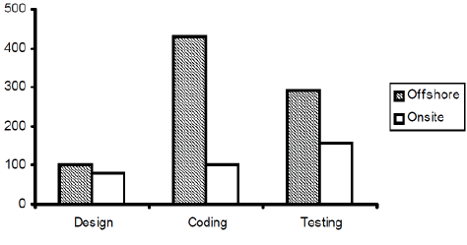

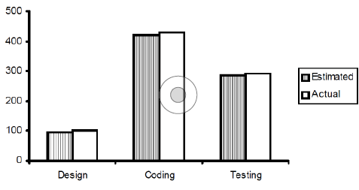

15. Which work requires as many man-hours as that spent in coding?

a. Offshore, design and coding

b. Offshore coding

c. Testing

d. Offshore, testing and coding

16. Roughly, what percentage of the total work is carried out onsite?

a. 40% b. 20 % c. 30 % d. 10 %

17. The total effort in man-hours spent onsite is nearest to which of the following?

a. The sum of the estimated and actual effort for offshore design

b. The estimated man-hours of offshore coding

c. The actual man-hours of offshore testing

d. Half of the man-hours of estimated offshore coding

18. If the total working hours were 100, which of the following tasks will account for approximately 50 hr?

a. Coding

b. Design

c. Offshore testing

d. Offshore testing plus design

19. If 50% of the offshore work were to be carried out onsite, with the distribution of effort between the tasks remaining the same, the proportion of testing carried out offshore would be

a. 40% b. 30% c. 50% d. 70%

20. If 50% of the offshore work were to be carried out onsite, with the distribution of effort between the tasks remaining the same, which of the following is true of all work carried out onsite?

a. The amount of coding done is greater than that of testing

b. The amount of coding done onsite is less than that of design done onsite

c. The amount of design carried out onsite is greater than that of testing

d. The amount of testing carried out offshore is greater than that of total design

**Practice Exercise – Medium**

**Directions (Q. Nos. 1 − 6):** *Answer the following questions on the basis of the information given below.*

The following bar chart represents numbers of voters who voted for TAP party as a percetage of eligible voters as well as the eligible voters as a percentage of total population of Delhi in various assembly elections.

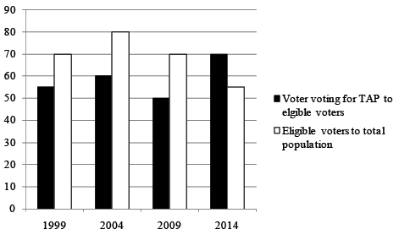

1. If the number of voters voting for TAP party for the year 2009 is 140 million, then the total population is?

a. 350 million b. 400 million

c. 530 million d. None of these

2. If the population of Delhi remains constant at 1 billion, what is the approximate average number of people voting for TAP in the 4 elections?

a. 43.5 million b. 44.25 million

c. 41.75 million d. None of these

3. If the number of voters voting for TAP remains unchanged for a given period then what does the trend the population of Delhi signify?

a. Population of Delhi steadily increases over the given period

b. Population of Delhi steadily decrease over the given period.

c. Population of Delhi steadily fluctuates over the given period.

d. None of these

4. Which year shows the highest increase in the difference between the population of Delhi and number of voters voting for TAP over the previous year, if eligible voters are same for each of the given years?

a. 1999 b. 2004

c. 2009 d. 2014

5. If we interchange the bars of ‘voter voting for TAP to eligible voters’ and ‘eligible voters to total population’ with each other, then which of the bars will represent inconsistency in data?

a. 1999 b. 2004

c. 2009 d. None of these

6. If the number of voters voting for TAP is constant for each of the years given above, then for which year is the population highest?

a. 1999 b. 2004

c. 2009 d. 2014

**Directions (Q. Nos. 7 − 11):** *Answer the following questions on the basis of the information given below.*

The bar charts show the runs scored by Rohit Sharma in ODI’s. Bar chart (1) gives the distribution of runs (in percentage) scored by him while Chart (2) gives total while batting at various positions against runs scored by him in 5 opponents. 3 countries as batting at various positions.

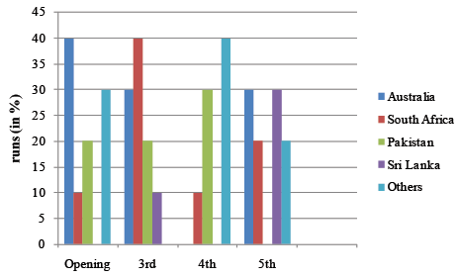

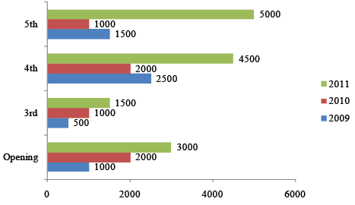

7. Across the given years, at which position he has scored the maximum number of runs?

a. Opening b. 3rd

c. 4th d. 5th

8. Against which country has Rohit scored most runs in 2009?

a. Pakistan b. Australia

c. Sri Lanka d. Others

9. Which position and which year has shown the maximum change over the previous position while playing against South Africa?

a. 4th , 2009 b. 3rd , 2011

c. 3rd , 2010 d. 5th , 2011

10. What is the maximum difference between runs scored against any 2 countries at any position?

a. 1550 b. 1300

c. 1450 d. None of these

11. Find the percentage change in runs scored by Rohit against Pakistan during 2010 over the previous year?

a. 14% b. 20% c. 25% d. 33%

**Directions (Q. Nos. 12 − 18):** *Answer the following questions on the basis of the information given below.*

The bar charts below show the divison of charity coming from different sources to the Human Foundation. The foundation received a total of 720 crores in donations in year 2014 and the donations have increased at a constant rate of 20% each year starting from 2012.

**A** - Individual donors

**B** - Institutional donors

**C** - Govt. donations

**D** - Chartity functions & fundraisers

**E** - Others

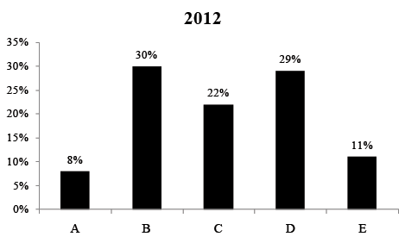

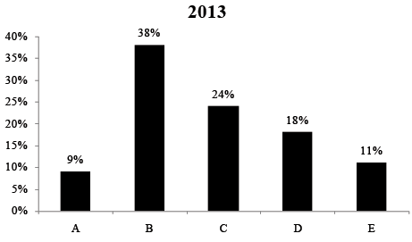

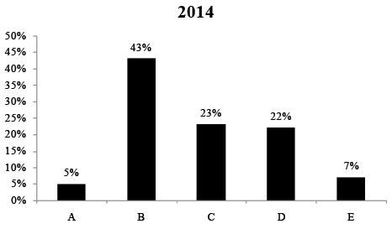

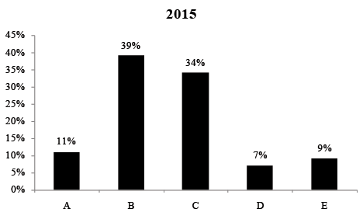

12. How many categories of donors have shown increase in each year for the given period?

a. 2 b. 3

c. 1 d. None

13. How many categories shows a decrease in donations each year as compared to previous year over the given period of time?

a. 2 b. 3

c. 1 d. None

14. The greatest absolute increase, between 2012 and 2015, in the donations form a category was observed for:

a. Charity functions & fundraisers

b. Govt. donations

c. Others

d. Institutional donors

15. For which category did the donations decrease between 2012 and 2015?

a. Institutional donors

b. Govt. donations

c. Charity functions & fundraisers

d. None of these

16. The greatest percentage increase, between 2012 and 2015, in the donations was observed in which category.

a. Charity functions & fundraisers

b. Govt. donations

c. Others

d. Individual donors

17. The highest donation in a category in any one year was for:

a. Institutional donors

b. Others

c. Govt. donations

d. individual donors

18. What is the difference in total fundings from Institutional donors and others for the given period?

a. 991.23 crores b. 1201.36 crores

c. 1116.58 crores d. 1482.26 crores

**Directions (Q. Nos. 19** − **22):** *Answer the following questions on the basis of the information given below.*

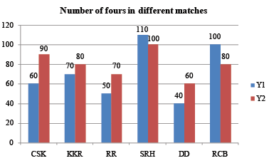

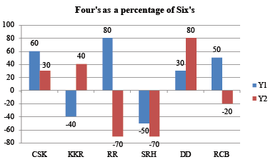

Chart (1) gives the number of fours in difference matches in year Y1 and Y2 and chart (2) gives the number fours as a percentage of number of sixes. If the value indicated in the chart is negative, then it is the number of sixes as a percentage of number of fours.

19. Find the difference in the total number of fours and sixes of team KKR in the year Y1 and Y2?

a. 150 b. 182 c. 130 d. 198

20. Find the average number of sixes in each team in the year Y2?

a. 92 b. 103 c. 118 d. 136

21. If 29% of the sixes of team RCB in the year Y1 and 37.5% sixes in the year Y2 are removed, then find the approximately ratio of number of sixes in the year Y1 to the number of sixes in the year Y2?

a. 14 b. 16 c. 11 d. 18

22. Which of the following is false?

a. Number of sixes of team CSK is maximum in the year Y2.

b. Number of sixes in year Y1 is greater than in year Y2 of team RR.

c. Number of sixes of team RR is minimum in the year Y2.

d. Number of sixes of team RCB has decreased in year Y2 as compared to that in Y1.

**Practice Exercise – Difficult**

**Directions (Q. Nos. 1 − 4):** *Answer the following questions on the basis of the information given below.*

A management institute was established on January 1, 2000 with 3, 4, 5, and 6 faculty members in the Marketing, Organisational Behaviour (OB), Finance, and Operations Management (OM) areas respectively, to start with. No faculty member retired or joined the institute in the first three months of the year 2000. In the next four years, the institute recruited one faculty member in each of the four areas. All these new faculty members, who joined the institute subsequently over the years, were 25 years old at the time of their joining the institute. All of them joined the institute on April 1. During these four years, one of the faculty members retired at the age of 60. The following diagram gives the area-wise average age (in terms of number of completed years) of faculty members as on April 1 of 2000, 2001, 2002, and 2003. **[CAT 2005]**

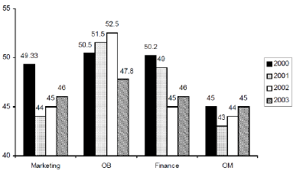

1. From which area did the faculty member retire?

a. Finance b. Marketing

c. OB d. OM

2. Professors Naresh and Devesh, two faculty members in the Marketing area, who have been with the Institute since its inception, share a birthday, which falls on 20th November. One was born in 1947 and the other one in 1950. On April 1 2005, what was the age of the third faculty member, who has been in the same area since inception?

a. 47 b. 50 c. 51 d. 52

3. In which year did the new faculty member join the Finance area?

a. 2000 b. 2001 c. 2002 d. 2003

4. What was the age of the new faculty member, who joined the OM area, as on April 1, 2003?

a. 25 b. 26 c. 27 d. 28

**Directions (Q. Nos. 5 − 8):** *Answer the following questions on the basis of the information given below.*

Purana and Naya are two brands of kitchen mixer-grinders available in the local market. Purana is an old brand that was introduced in 1990, while Naya was introduced in 1997. For both these brands, 20% of the mixer-grinders bought in a particular year are disposed off as junk exactly two years later. It is known that 10 Purana mixer-grinders were disposed off in 1997. The following figures show the number of Purana and

Naya mixer-grinders in operation from 1995 to 2000, as at the end of the year.

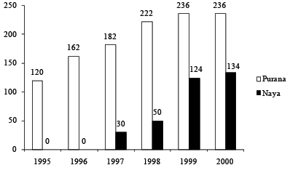

5. How many Naya mixer-grinders were purchased in 1999?

a. 44 b. 50 c. 55 d. 64

6. How many Naya mixer-grinders were disposed off by the end of 2000?

a. 10 b. 16

c. 22 d. Cannot be determined

7. How many Purana mixer-grinders were disposed off in 2000?

a. 0 b. 5

c. 6 d. Cannot be determined

8. How many Purana mixer-grinders were purchased in 1999?

a. 20 b. 23

c. 50 d. Cannot be determined

**Directions (Q. Nos. 9 − 13):** *Answer the following questions on the basis of the information given below.*

Bearson, a leading educational service provider develops questions for an entrance examination. The questions are developed in 10 different topics viz. A, B, C, D, E, F, G, H, I and J. the bar charts below show the data of number of question from each topic.

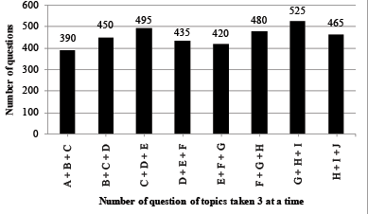

The total number of questions developed on topics A to E is 720 and on B to F is 675.

9. How many questions here developed from topic F?

a. 135 b. 105

c. 75 d. Cannot be determined

10. For how many subjects can we find the exact number of questions?

a. 0 b. 5

c. 3 d. None of these

11. How many of the following statements are definitely false?

I. Questions developed on topic B is more than questions on topic E.

II. Questions developed on topic C is more than questions on topic E.

III. Questions developed on topic A and B together is more than questions developed on topic D and E together.

IV. Questions developed on topic B and C together is more than the questions developed on topic C and D together.

a. 0 b. 1

c. 2 d. 3

12. In the question above how many statements can be definitely proven to be true or false?

a. 0 b. 1

c. 2 d. None of these

13. How many of the following statements will be required to find the number of questions from each topic?

I. total number of questions on all the topics.

II. Total number of questions developed taking 4 subjects at a time.

III. Difference of number of questions taking 2 subjects at a time.

a. 0 b. 1

c. 2 d. 3

**Directions (Q. Nos. 14 − 17):**  *Answer the following questions on the basis of the information given below.*

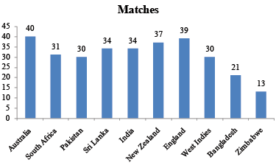

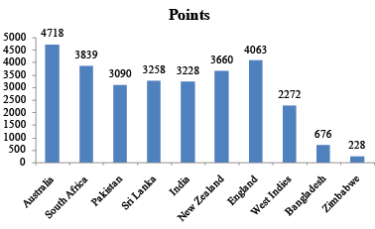

The points are awarded in the following manner.

⇒ In any test, if any team beats another team ranked higher than it, the winning team will get 92 points and 92 points will be deduced from the losing team.

⇒ If any team defeats another team ranked equal or lower to it then it will get 46 points and 46 points will be deduced from the losing team.

⇒ In case of draw, each team will get 22 points.

The teams are ranked according rating, which is calcualted as:

Rating = 

All the points are awarded at completion of series and on basis of ranking before the series.

**Forthcoming Series:**

England vs. West Indies (3 tests)

Pakistan vs. Bangladesh (2 tests)

New Zealand vs. England (2 tests)

Australia vs. West Indies (2 tests)

Pakistan vs. Sri Lanka (3 tests)

England vs. Australia (5 tests)

South Africa vs. Bangladesh (2 tests)

England vs. South Africa (4 tests)

14. What are the least rating that England can finish at the end of schedule?

a. 99 b. 62

c. 89 d. None of these

15. ACB (Australian Cricket Board) can organize an optional series with team India (max 3 tests) to boost the rating of Australian team to make it rank 1. Which of the following is correct?

a. Australia can become Rank 1 without this series.

b. Australia cannot become Rank 1 even by playing this series.

c. Australia need to win atleast 2 matches of this series to be rank 1.

d. Nothing can be said.

16. How many team/s has the chance of winning the ICC test championship by attaining rank 1?

a. 1 b. 2

c. 3 d. More than 3

17. What can be the least rank England can finish at?

a. 6th b. 8th

c. 9th d. 5th